**How To Create Linux VM In Azure**

Well, we have discussed above, **How to create a Windows virtual machine in the Azure portal**. Now let’s discuss here, **how to create Linux Virtual Machine in Azure.**

**How To Create Virtual Machine In Azure Step By Step**

**Step-1:**Follow the **step-1 to Step-2** from the above section.

**Step-2:**On the **Create a Virtual Machine** page, Provide the below details

* **Subscription**: Select a **valid subscription** that you want to use here to create a**Linux virtual machine**.
* **Resource group**: Choose the existing resource group or you can create a new one by clicking the “**Create New**” option.
* **Virtual machine name**: You need to provide a name for your virtual machine.
* **Region**: Select the **region**or **location**.
* **Image**: Choose the **Ubuntu Server 20.04 LTS – Gen1**as the **image**option.
* **Size**: Select the size based on your business requirement. Click on the **see all sizes** link to check all the options available.
* **Authentication Type:**Select the **authentication type** based on your need.
* **Username**: Provide a username.
* **SSH public key source:** Select the default option **Generate new key pair**.
* **Key Pair Name:**Provide a name for the key pair.
* **Public inbound Ports:**Select the **Allow selected ports** option.
* **Select Inbound Ports:**Select the **HTTP (80), SSH (22)** option.

Keep the other tab values as it is, Finally click on the **Review + Create** button.

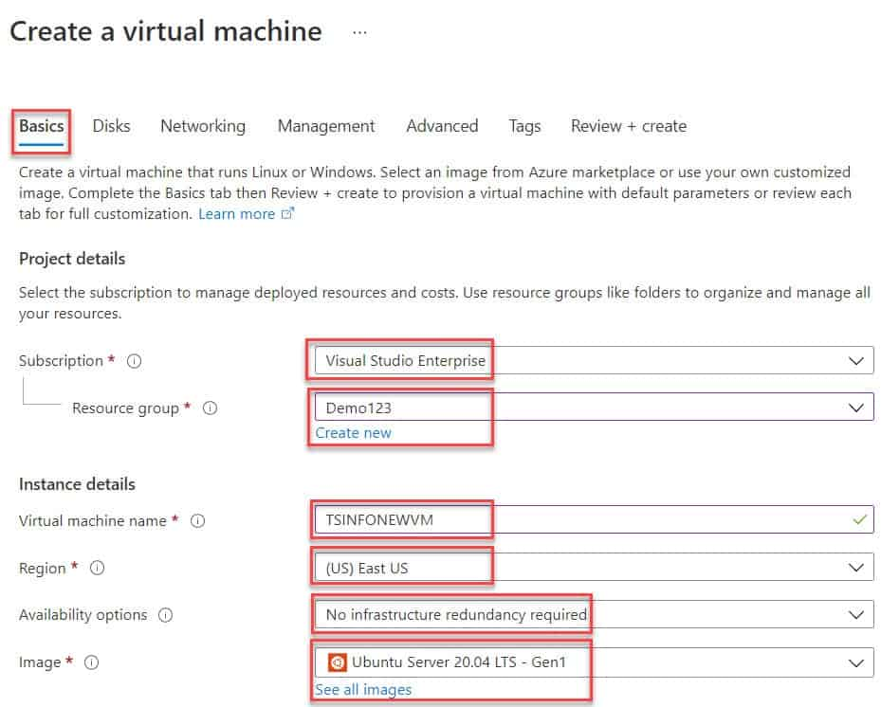

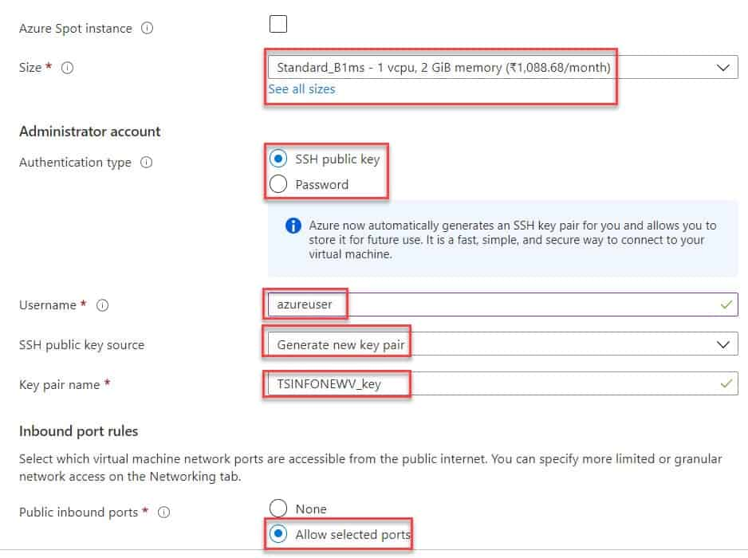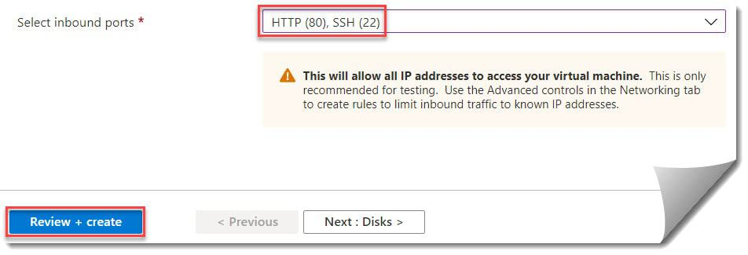how to create a vm in azure portal step by step

**Step-3:** Now, it will validate all the details provided by you and will show you **Validation Passed**. Click on the **Create**button to create the **Azure Linux Virtual Machine**.

**Step-4:**Click on the **Download private key and create resource** button to download the key details that you need while connecting the virtual machine.

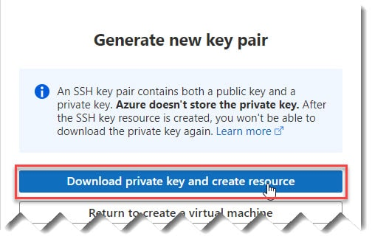

**Step-5:** It will take a few minutes and then will show you that **Your deployment is complete**. Click on the **Go to Resource** button to navigate to the**Linux Virtual Machine** that you have created.

